
COIT20265-Networks and Information Security Project
Term 1, 2026
Assignment 1 –Project Proposal

Prepared by:
Suhartanto Tanuwijaya (12290667)
Dev Anand Suresh
Sai Teja Akula

Campus: Sydney
Tutor: Biplob Ray
Table of Contents
Overview 3
Project Background and Justification 3
Problem Statement 3
Project Objective 3
Project Scope 3
Implement Management Overview 3
Tasks 4
Roles 5
Roles 5
Responsibilities 5
Resources Requirements 6
In-kind 6
Cash 6
Personnel 7
Project Risk and Mitigation 7
Schedule 7
Ethical and Professional Issue 7

Overview

Project Background and Justification
Key points need to be explain:
- Topic of project :
  - Literature Review : IoT Security Challenges
  - Example Application of Supervised machine learning in network intrusion detection.

Problem Statement
Key points need to be explain:
- Whats is the problem you are going to solve?

Project Objective
Key points need to be explain:
- When this project has done , it could be benefit for whom ? and what are benefits ?
- Whats the aim of project

Project Scope
Key points need to be explain:
- What you are not going to do ( out of scope)
- What are we going to do :
  - Collect dataset : Secondary data collection
      - 100 GB raw network packets has been captured by using TCP dump , formed into Pcap file and the dataset has been classified into several type of attacks based on conducted study by Moustafa et.al (2015)
      - NSL-KDD dataset has been collected by McHungh (2000)
  - Analyse and classify dataset
  - Develop a Network Intrusion Detection Systems (NIDS) machine learning by using python programming language

Implement Management Overview
Key points need to be explain:
- How you will approach ?
- WBS

Note :
- Example of Implementation Approaches :
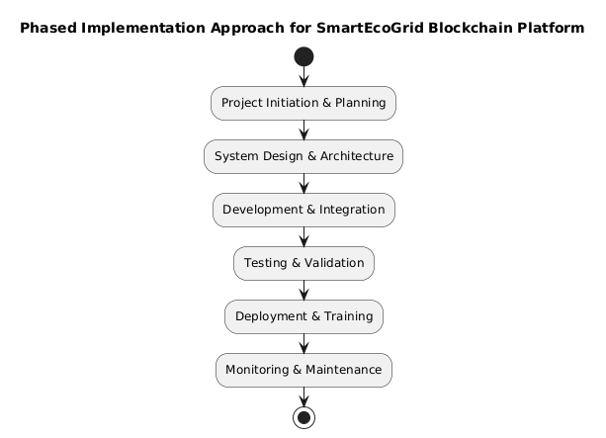

- Whats the topic of projects ( Introduction )
- What are you going to do?

Note:
- this section must be written for non-technical audience such as management , CEO and project manager of your client.
- Also, contain some technical contents about what your going to do and it should be written for IT employee of your client.

Tasks
- List the detail tasks you plan to do in your project
Task | Description | Deliverables
Data collection | Collecting network data has been captured and identify which traffic would be identified as malicious or normal | - Scatterplot Visual  - Table of attribute dataframe  - Table of evaluated attributes
Analysis Malicious Traffic
Literature Collection
Analysis Threat and Warning Indicator
Programming
Training and Optimization
Documentation
Testing Prototype
Collect KPI and Adjustment
Presentation
Final Documentation

Roles

Roles
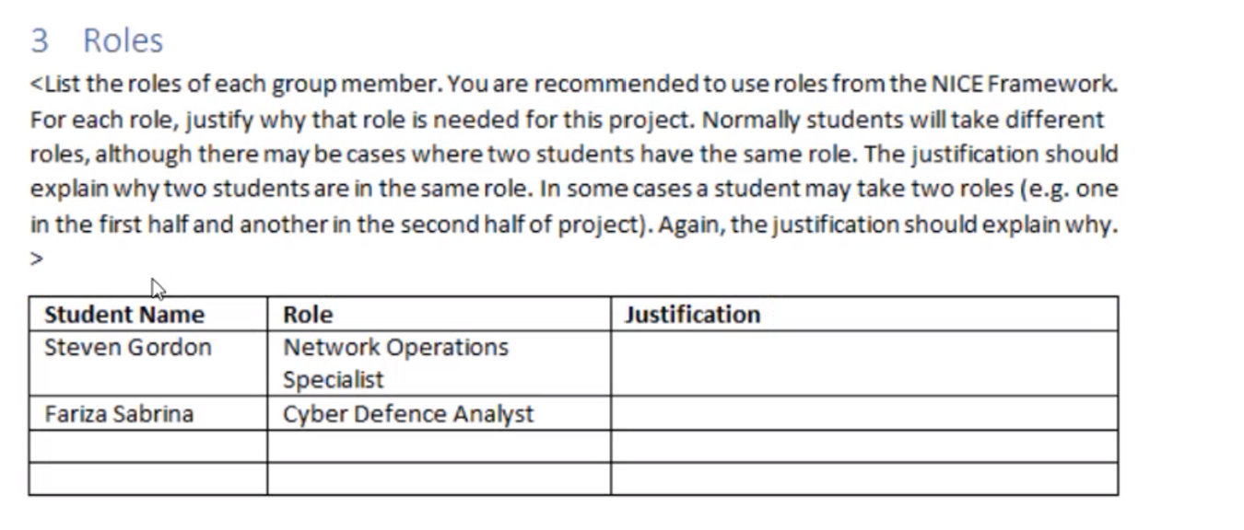
Student Name | Role | Justification
Suhartanto Tanuwijaya | All-Source Analyst | Gather and Analyse multiple credible intelligence requirements sources such as Journals and studies to support planning and operations of project
Suhartanto , Dev Anand Suresh | Software Developer | Develop Machine Learning Program by using Python programming language and libraries.
Suhartanto Tanuwijaya | Threat / Warning Analyst | Develop and determine cyber threat Indicator as either malicious traffic or normal traffic.
Suhartanto Tanuwijaya | Research & Development Specialist | Conduct literature review research to develop new capabilities of detection malicious network traffic by using machine learning model
 | System Testing and Evaluation Specialist | Conduct a testing test cases to ensure developed machine learning able to detect intrusion system

Responsibilities
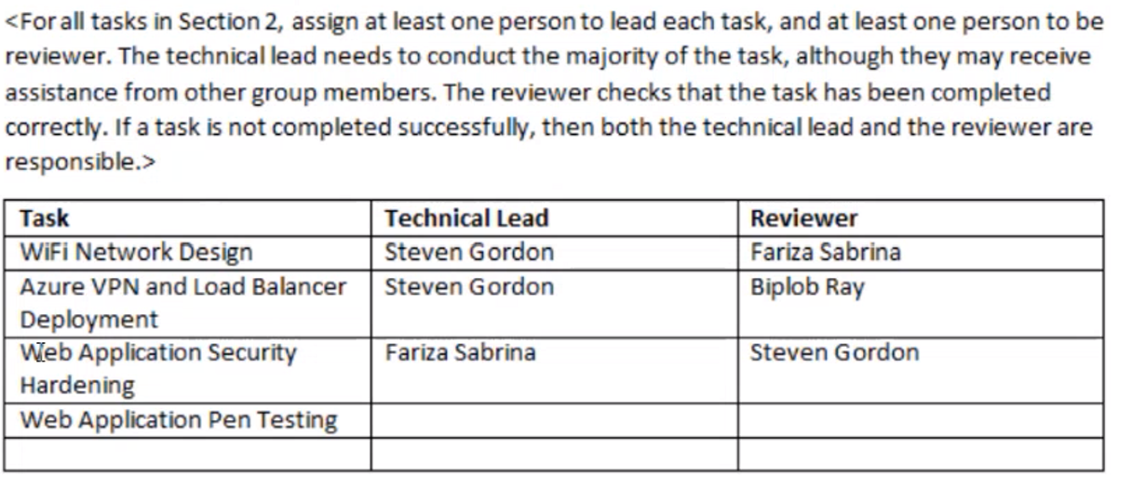
Task | Technical Lead | Reviewer
Data Collection | Suhartanto Tanuwijaya
Analysis Malicious Traffic | Suhartanto Tanuwijaya
Literature Collection | Suhartanto Tanuwijaya
Analysis Threat and Warning Indicator
Programming
Training and Optimization
Documentation
Testing Prototype
Collect KPI and Adjustment
Presentation
Final Documentation

Resources Requirements
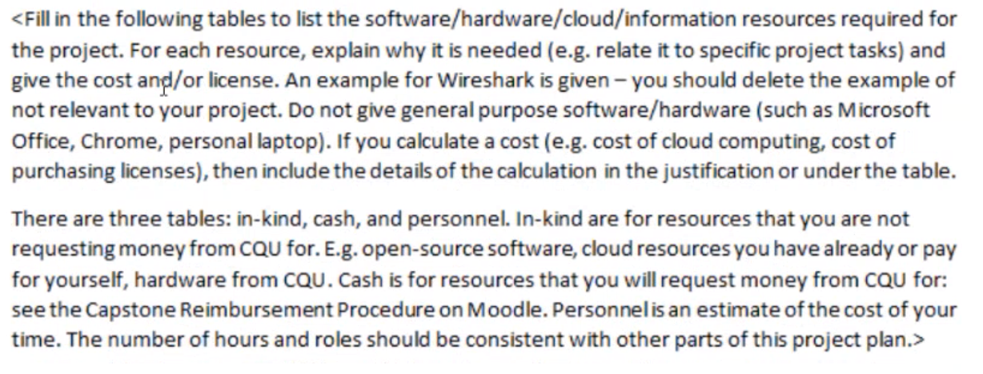

In-kind
Resource | Justification | Cost/License
Wireshark | Packet has been captured would be used in data collection task to categorize the attributes and classify classes | Free, GNU GPL Open Source
Microsoft Project | Scheduling project timeline and milestones need to be achieved including resources. | Free,
Weka |  | Free

Cash
Resource | Justification | Cost
Google Colab Pro | Data has been captured , would be evaluate by using Google Colab Pro and training as well for create a new machine learning model  Google Colab Pro would provide better compute specification , which is it could able to machine training and evaluate data faster than free plan | $ 75.62 per month

Personnel
Resources | Justification | Cost
Data Analyst |  | $150 per hour
Programmer

Project Risk and Mitigation
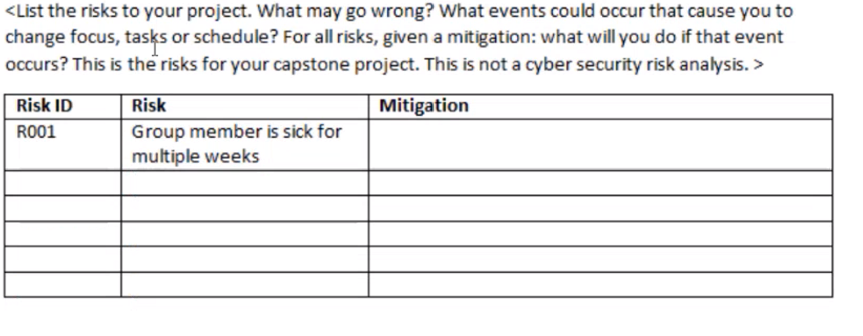
Risk ID | Risk | Mitigation
R001 | Group Member Sick during Training or collecting data | Find a secondary dataframe from credible sources, such as UNSW , McKinsey and other data firm
R002 | Google Collab having downtime | Find other platform who are able to perfom machine learning such as Juypyter Notebook

Schedule
- Gantt Chart ( MS Project ) – All tasks

Ethical and Professional Issue

